**Learning Outcome - Able to understand Scripting and styling the web**

After achieving this learning outcome, a student will be able to understand structuring the web. In order to achieve this learning outcome, a student has to complete the following:

1. Apply CSS within a webpage (1Hrs)

2. Apply CSS to HTML (1Hrs)

3. Select elements via element name, class or ID (1 Hrs)

4. Select elements via attribute name and content (1 Hrs)

5. Apply pseudo-elements (1 Hrs)

6. Specify colors in CSS (1 Hrs)

7. Debug CSS in the browser (1 Hrs)

8. Style text and customize a list of elements (1 Hrs)

9. Add shadows to text (1 Hrs)

10. Size CSS boxes (1 Hrs)

11. Control overflowing content (1 Hr)

12. Control the part of a CSS box to draw the background (1 Hrs)

13. Create fancy boxes (also see the Styling boxes module, generally). (1 Hrs)

14. Use background-clip to control background image ( 1Hrs)

15. Change the box model completely using box- sizing (1Hrs)

16. Control backgrounds (1 Hrs)

17. Apply control borders(1 Hrs)

18. Style an HTML table (1 Hrs)

19. Add shadows to boxes (1 Hrs)

20. Calculate specificity of a CSS selector (1 Hrs)

21. Control inheritance in CSS (1 Hrs)

22. Apply filters in CSS (1 Hrs)

23. Apply blend modes in CSS (1 Hrs)

24. Apply CSS multi-column layouts (1 Hrs)

25. Apply CSS generated content (1 Hrs)

**Activity 1**

**Aim:** Apply CSS within a webpage (2Hrs)

**Learning outcome:** Able to script and style the web.

**Duration:** 1 hours

**List of Hardware/Software requirements:**

1. A computer with Windows/Linux/Mac operating system.

2. Any latest browser installed.

3. Visual studio code / Notepad++/ Sublime text

**Code/Program/Procedure (with comments):**

<!DOCTYPE html>

<html>

<head>

<style>

body {background-color: powderblue;} /* setting background color for body element */

h1 {color: blue;} /* setting color for h1 element */

p {color: red;} /* setting color for paragraph element */

</style>

</head>

<body>

<h1>This is a heading</h1>

<p>This is a paragraph.</p>

</body>

</html>

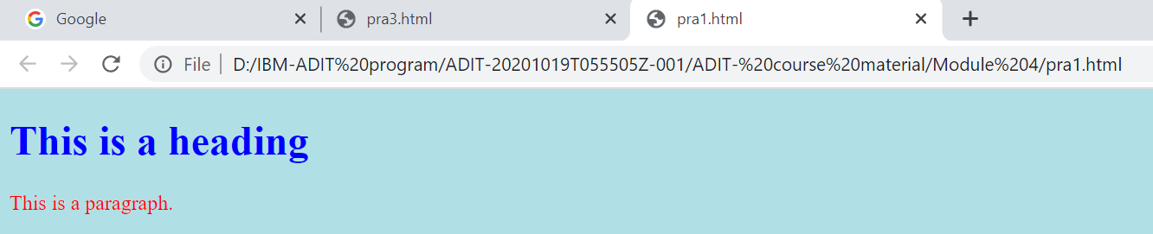**Output/Results snippet:**

**References:**

● <https://www.w3schools.com/html/html_css.asp>

**Activity 2**

**Aim:** Apply CSS to HTML

**Learning outcome:** Able to script and style the web.

**Duration:** 1 hours

**List of Hardware/Software requirements:**

1. A computer with Windows/Linux/Mac operating system.

2. Any latest browser installed.

3. Visual studio code / Notepad++/ Sublime text

**Code/Program/Procedure (with comments):**

<!DOCTYPE html>

<html>

<head>

<link rel="stylesheet" href="style.css"> <!-- Linking the external .css file to this html doc-->

</head>

<body>

<h1>This is a heading</h1>

<p>This is a paragraph.</p>

</body>

</html>

**style.css**

/* here only the css rules are coded and this file need to be imported in html file for use */

body {

background-color: powderblue;

}

h1 {

color: blue;

}

p {

color: red;

}

**Output/Results snippet:**



**References:**

● <https://www.w3schools.com/html/html_css.asp>

**Activity 3**

**Aim:** Select elements via element name, class or ID (2 Hrs) **Learning outcome:** Able to script and style the web. **Duration:** 1 hours

**List of Hardware/Software requirements:**

1. A computer with Windows/Linux/Mac operating system.

2. Any latest browser installed.

3. Visual studio code / Notepad++/ Sublime text

**Code/Program/Procedure (with comments):**

<!DOCTYPE html>

<html>

<head>

<style>

.center { /* setting the css rules for center class */

text-align: center;

color: red;

}

</style>

</head>

<body>

<h1 class="center">Red and center-aligned heading</h1> /*applying the effect of class center*/

<p class="center">Red and center-aligned paragraph.</p> /*applying the effect of class center*/

</body>

</html>

**Output/Results snippet:**

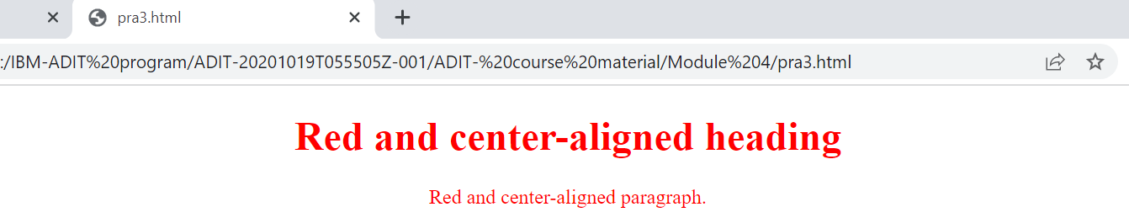

**References:**

● <https://www.w3schools.com/css/css_selectors.asp>

**Activity 4**

**Aim:** Select elements via attribute name and content (1 Hrs) **Learning outcome:** Able to script and style the web. **Duration:** 1 hours

**List of Hardware/Software requirements:**

1. A computer with Windows/Linux/Mac operating system.

2. Any latest browser installed.

3. Visual studio code / Notepad++/ Sublime text

**Code/Program/Procedure (with comments):**

<!DOCTYPE html>

<html>

<head>

<style>

input[type="text"] { /* sets the css rule for textbox element*/

width: 150px;

display: block;

margin-bottom: 10px;

background-color: yellow;

}

input[type="button"] { /* sets the css rule for button element*/

width: 120px; margin-left: 35px; display: block;

}

</style>

</head>

<body>

<form name="input" action="" method="get">

Firstname:<input type="text" name="Name" value="Priyanka" size="20"> Lastname:<input type="text" name="Name" value="Patel" size="20">

**Output/Results snippet:**

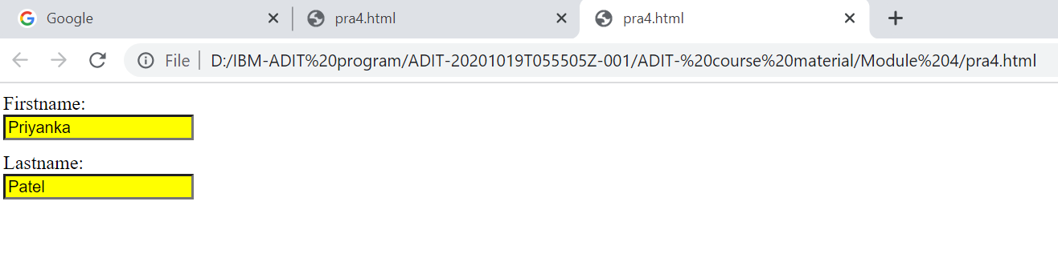

**References:**

● <https://www.w3schools.com/css/css_attribute_selectors.asp>

**Activity 5**

**Aim:** Apply pseudo-elements (2 Hrs)

**Learning outcome:** Able to script and style the web.

**Duration:** 1 hours

**List of Hardware/Software requirements:**

1. A computer with Windows/Linux/Mac operating system.

2. Any latest browser installed.

3. Visual studio code / Notepad++/ Sublime text

**Code/Program/Procedure (with comments):**

<!DOCTYPE html>

<html>

<head>

<style>

p.intro::first-letter { /* sets the css rule of intro class for its first-letter */

color: #ff0000;

font-size:200%;

}

</style>

</head>

<body>

<p class="intro">This is an introduction.</p> /*applying the effects of intro class*/

<p>This is a paragraph with some text. A bit more text even.</p>

</body>

</html>

**Output/Results snippet:**

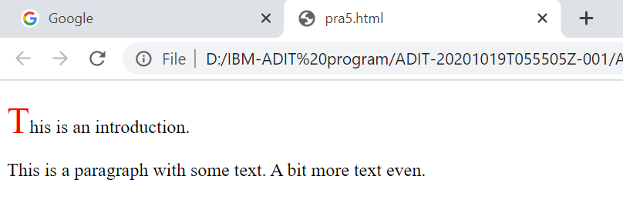

**References:**

● <https://www.w3schools.com/css/css_pseudo_elements.asp>

**Activity 6**

**Aim:** Specify colors in CSS (5 Hrs) **Learning outcome:** Specify colors in CSS. **Duration:** 1 hour

**List of Hardware/Software requirements:**

● Visual studio code / Notepad++/ Sublime text

● Any One web browser

**Code/Program/Procedure (with comments):**

<!DOCTYPE html>

<html lang="en">

<head>

<meta charset="utf-8">

<title>CSS Color</title>

<style>

/* Using Color Name */

#col {

color: red;

}

/* Using Hexadecimal Color code */

#hex {

color: #00ff00;

}

/* Using RGB() */

#rgb {

color: rgb(255, 165, 0);

}

/* Using RGBA() */

#rgba {

color: rgba(255, 0, 0, 1);

}

/* Using HSLA */

#hsla {

color: hsla(120, 100%, 25%, 0.3);

}

</style>

</head>

<body>

<p id="col">Specify Colors in CSS using Color Names</h1>

<p id ="hex">Specify Colors in CSS using Hexadecimal Notation</p>

<p id = "rgb">Specify Colors in CSS using RGB Values</h2>

<p id="rgba">Specify Colors in CSS using rgba() Values</p>

<p id="hsla">Specify Colors in CSS using HSLA() Values</p>

</body>

</html>

**Output/Results snippet:**

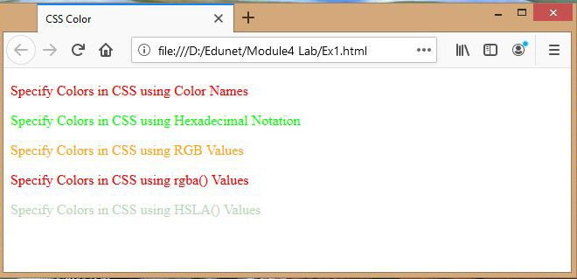

**References:**

● <https://developer.mozilla.org/en-US/docs/Web/CSS>

**Activity 7**

**Aim:** Debug CSS in the browser.

**Learning outcome:** Scripting and styling the web

**Duration:** 1 hour

**List of Hardware/Software requirements:**

● Visual studio code / Notepad++/ Sublime text

● Any One web browser, Mozilla Firefox recommended.

**Code/Program/Procedure (with comments):**

● Right click on the element which you want to inspect and click on the **Inspect Element**.

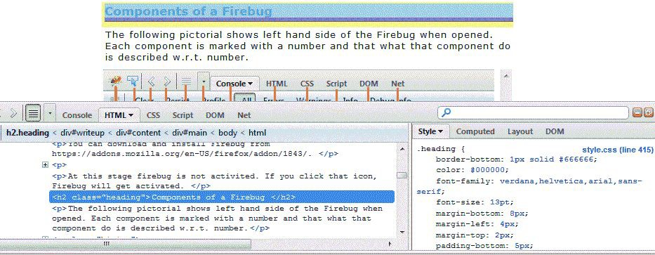

● Click on the **Edit** in the Firebug window now.

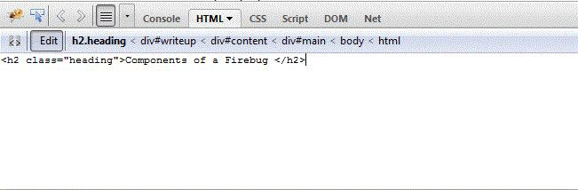

● Change the code to <h1>Components of Firebug</h1> .

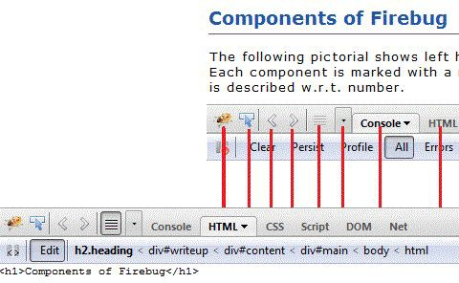

As soon as you change the code, you can see the effect live. You can copy the code and then simply paste it replacing the original code and save to make the effect permanent.

**Inspect and edit CSS with Firebug**

● Right click on the element which you want to inspect and click on the **Inspect Element**.

A then click as shown (scroll the image to right) in the image to open corresponding CSS

code.

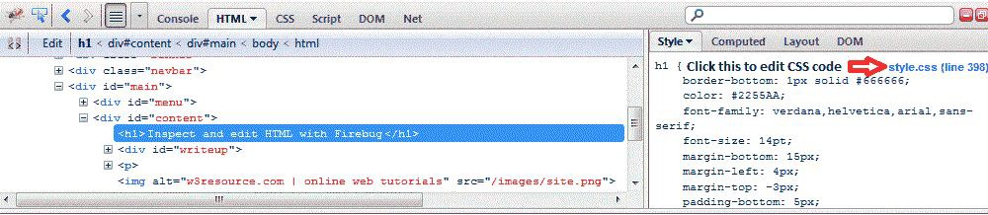

● Change the color of the heading by changing the code to colour: red;

● You will see the effect live immediately. Now you can simple copy this and replace the original code and save to make the changes permanent

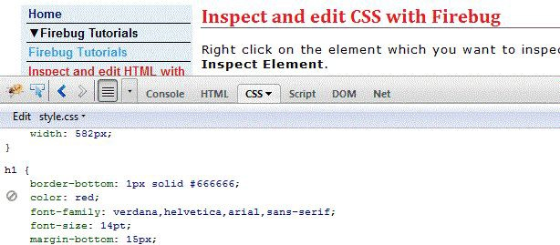

**Output/Results snippet:**

● Edit and save successfully.

**References:**

● <https://developer.mozilla.org/en-US/docs/Web/CSS>

● [https://developer.mozilla.org/en-US/docs/Tools/Page_Inspector/How_to/Examine_and_e dit_HTML](https://developer.mozilla.org/en-US/docs/Tools/Page_Inspector/How_to/Examine_and_edit_HTML)

**Activity 8**

**Aim:** Style text and customize a list of elements.

**Learning outcome:** Scripting and styling the web (1 Hrs)

**Duration:** 1 hour

**List of Hardware/Software requirements:**

● Visual studio code / Notepad++/ Sublime text

● Any One web browser

**Code/Program/Procedure (with comments):**

<!DOCTYPE html>

<html>

<head>

<title>CSS Text Color</title>

<style>

/* Text Properties*/

#txt {

text-align: justify;

text-indent: 35px;

text-transform: capitalize;

letter-spacing: 5px; word-spacing: 25px; white-space: pre;

text-shadow: 4px 4px 8px orange;

font-style: italic;

}

/* Unorderd List*/

ul.unol1 {

list-style-type: circle;

}

ul.unol2 {

list-style-type: square;

}

/* Orderd List */

ol.ol1 {

list-style-type: upper-roman;

}

ol.ol2 {

list-style-type: lower-alpha;

}

</style>

</head>

<body>

<p id="txt">

Hello, this is example of CSS text-align justify type. Its like newspaper or book type.

</p>

<p>Example of UnOrdered lists:</p>

<ul class="unol1">

<li>HTML5</li>

<li>CSS3</li>

<li>JAVASCRIPT</li>

</ul>

<ul class="unol2">

<li>Typescript</li>

<li>Bootstrap</li>

<li>JQuery</li>

</ul>

<p>Example of ordered lists:</p>

<ol class="ol1">

<li>C</li>

<li>Java</li>

<li>Python</li>

</ol>

<ol class="ol2">

<li>Mozila firefox</li>

<li>Chromium</li>

<li>EPIC</li>

</ol>

</body>

</html>

**Output/Results snippet:**

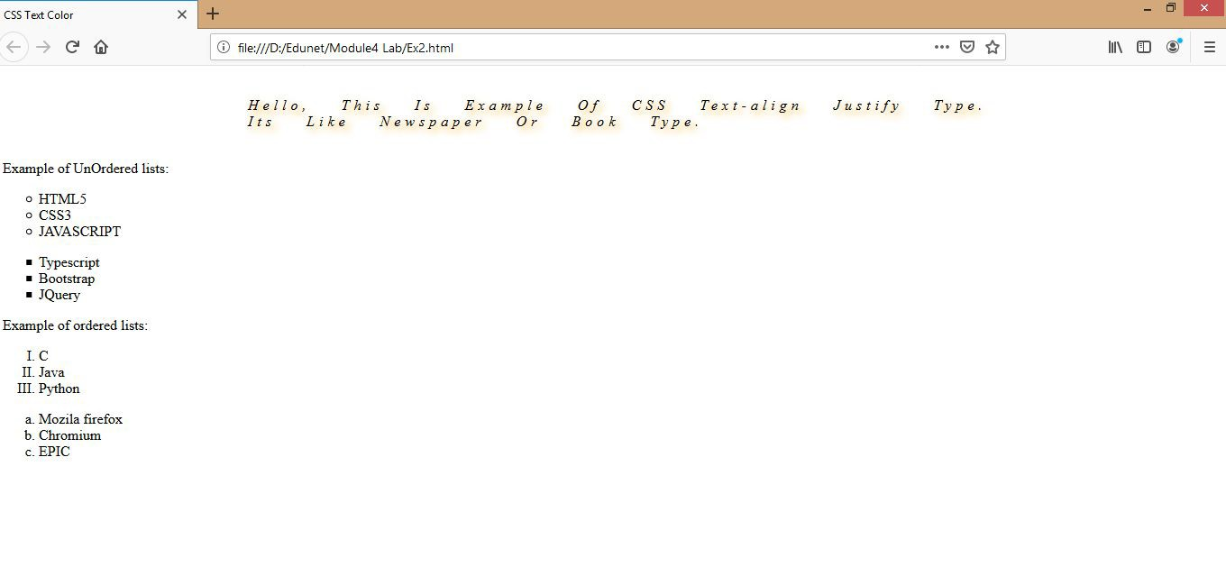

**References:**

● <https://developer.mozilla.org/en-US/docs/Web/CSS>

**Activity 9**

**Aim:** Add shadows to text.

**Learning outcome:** Scripting and styling the web

**Duration:** 1 Hrs

**List of Hardware/Software requirements:**

● Visual studio code / Notepad++/ Sublime text

● Any One web browser

**Code/Program/Procedure (with comments):**

<!DOCTYPE html>

<html lang="en">

<head>

<meta charset="utf-8">

<title>CSS Text Shadow Effect</title>

<style>

/* CSS Text Shadow Effect */

p{

font: 26px sans-serif;

}

p.shadow{

text-shadow: 1px 1px 2px rgba(0, 0, 0, 0.6);

}

p.shadow-multiple{

text-shadow: 2px 2px 3px yellow, 3px 3px 5px red;

}

p.shadow-outline{

color: #fff;

text-shadow: -1px 0 #000, 0 1px #000, 1px 0 #000, 0 -1px #000;

}

</style>

</head>

<body>

<p class="shadow">This is a simple example of text shadow effect.<

/p>

<p class="shadow-multiple">This is a simple example of multiple te

xt shadow effect.</p>

<p class="shadow-outline">this is another example of multiple text shadow effect. </p>

</body>

</html>

**Output/Results snippet:**

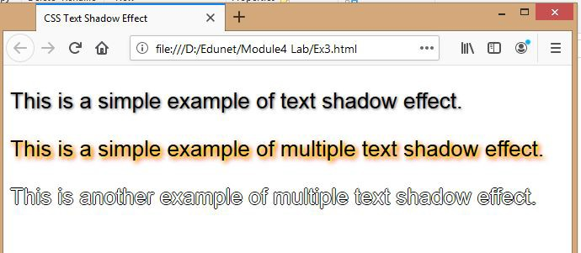

**References:**

● <https://developer.mozilla.org/en-US/docs/Web/CSS>

**Activity 10**

**Aim:** Size CSS Boxes

**Learning outcome:** Scripting and styling the web

**Duration:** 1 hour

**List of Hardware/Software requirements:**

● Visual studio code / Notepad++/ Sublime text

● Any One web browser

**Code/Program/Procedure (with comments):**

<!DOCTYPE html>

<html>

<head>

<style>

/* CSS Box Properties */

#example1 {

border: 10px dashed black;

padding: 25px;

background: url(edu.jpg);

background-repeat: no-repeat;

background-origin: content-box, padding-box;

}

#example2 {

border: 10px dashed black;

padding: 25px;

background: url(edu.jpg);

background-repeat: no-repeat;

background-origin: content-box, border-box;

}

#example3 {

border: 10px dashed black;

padding: 25px;

background: url(edu.jpg);

background-repeat: no-repeat;

background-origin: content-box, content-box;

}

</style>

</head>

<body>

<h2>background-origin: content-box, padding-box:</h2>

<div id="example1">

<h2>Hello World</h2>

<p>The "edu.jpg" background image starts from the upper left corner of the padding edge.</p>

<p>The "edu.jpg" background image starts from the upper left corner of the content.</p>

</div>

<h2>background-origin: content-box, border-box:</h2>

<div id="example2">

<h2>Hello World</h2>

<p>The "edu.jpg" background image starts from the upper left corner of the border.</p>

<p>The "edu.jpg" background image starts from the upper left corner of the content.</p>

</div>

<h2>background-origin: content-box, content-box:</h2>

<div id="example3">

<h2>Hello World</h2>

<p>Both background images starts from the upper left corner of the c ontent.</p>

</div>

</body>

</html>

**Output/Results snippet:**

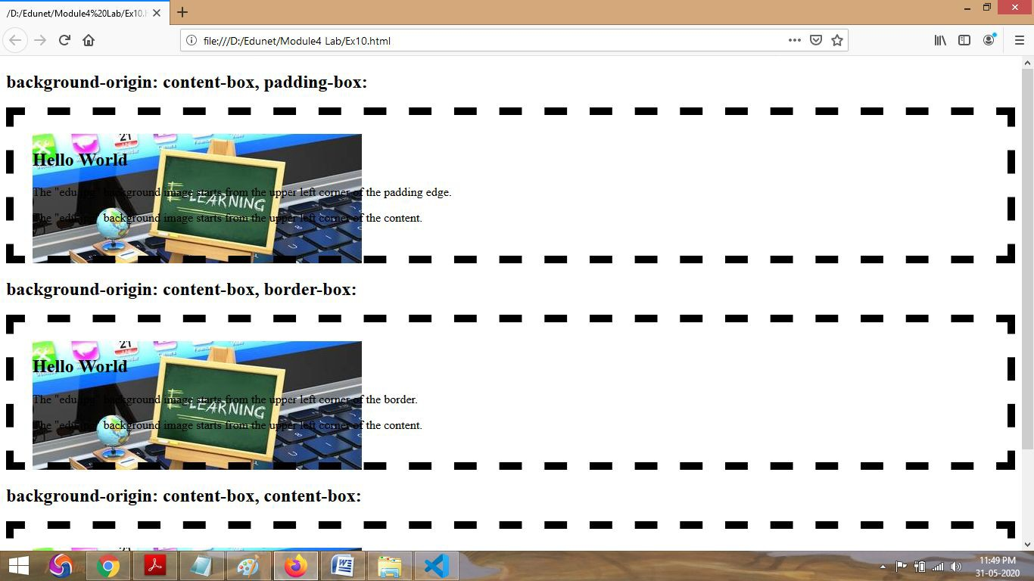

**References:**

● <https://developer.mozilla.org/en-US/docs/Web/CSS>

**Activity 11**

**Aim:** Control overflowing content.

**Learning outcome:** Scripting and styling the web (1 Hrs)

**Duration:** 1 hour

**List of Hardware/Software requirements:**

● Visual studio code / Notepad++/ Sublime text

● Any One web browser

**Code/Program/Procedure (with comments):**

<!DOCTYPE html>

<html>

<head>

<style>

/* Overflow – Visible, Hidden, Scroll, Auto */

#overflow-visible {

background-color: #cccccc;

width: 200px;

height: 50px;

border: 2px solid red;

overflow: visible;

}

#overflow-hidden {

background-color: #cccccc;

width: 200px;

height: 50px;

border: 1px solid red;

overflow: hidden;

}

#overflow-scroll {

background-color: #cccccc;

width: 200px;

height: 50px;

border: 1px solid red;

overflow: scroll;

}

#overflow-auto {

background-color: #cccccc;

width: 200px;

height: 50px;

border: 1px solid red;

overflow: auto;

}

</style>

</head>

<body>

<h2>This is CSS Overflow!</h2>

<p>See the extra content visible out of the element.</p>

<div id="overflow-visible">overflow-visible. </div>

<h2>This is CSS Overflow (hidden)!</h2>

<p>See the extra content out of the element?</p>

<div id="overflow-hidden">overflow-hidden.</div>

<h2>This is CSS Overflow (scroll)!</h2>

<p>See a new scroll bar?</p>

<div id="overflow-scroll">overflow-scroll</div>

<h2>This is CSS Overflow (scroll)!</h2>

<p>See a new vertical scroll bar?</p>

<div id="overflow-auto">overflow-auto</div>

</body>

</html>

**Output/Results snippet:**

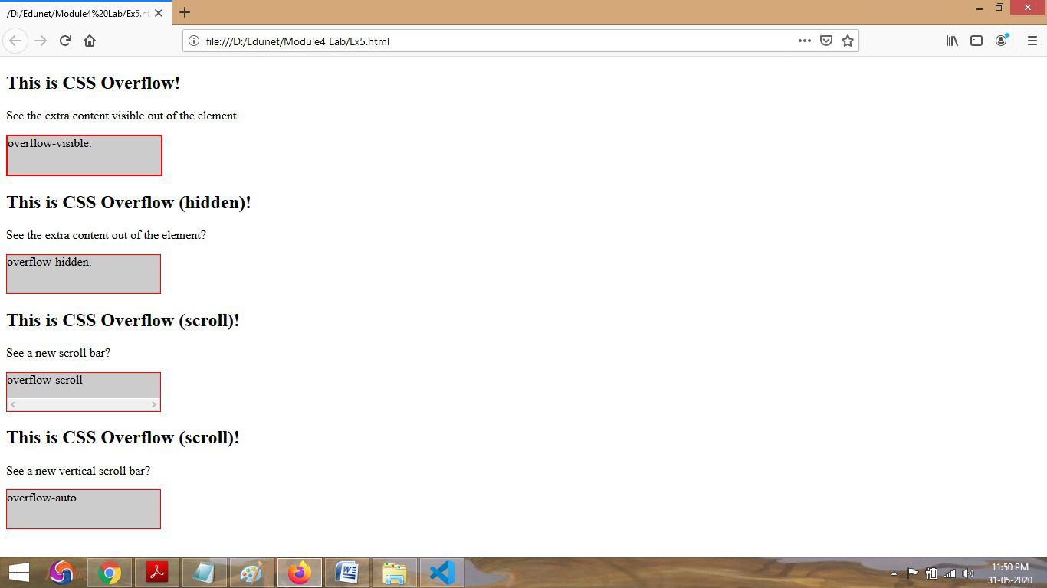

**References:**

● <https://developer.mozilla.org/en-US/docs/Web/CSS>

**Activity 12**

**Aim:** Control the part of a CSS box to draw the background.

**Learning outcome:** Scripting and styling the web

**Duration:** 1 hour

**List of Hardware/Software requirements:**

● Visual studio code / Notepad++/ Sublime text

● Any One web browser

**Code/Program/Procedure (with comments):**

<!DOCTYPE html>

<html>

<head>

<style>

/* CSS Box to draw background */

body {

background-color: #F5F5F5;

color: #555;

font-size: 1.1em;

font-family: 'Helvetica Neue', Helvetica, Arial, sans-seri

f;

}

.container {

margin: 40px auto;

width: 80%;

}

.el {

padding: 40px;

margin-bottom: 30px; background-color: #0099cc; color: white;

border: 30px solid rgba(224, 30, 108, 0.3);

background-image: url(edu.jpg);

}

.el-2 {

background-clip: padding-box;

}

.el p {

padding: 20px;

margin: 0;

font-size: large;

font-family: 'Lucida Sans', 'Lucida Sans Regular', 'Lucida

Grande', 'Lucida Sans Unicode', Geneva, Verdana, sans-serif;

color: red;

}

</style>

</head>

<body>

<div class="container">

<div class="el el-1">

<p>

My background painting area has the default <code>bord er-box</code> value.

</p>

</div>

<div class="el el-2">

<p>

My background painting area has the value <code>paddin g-box</code>. No background is painted under the

border.

</p>

</div>

</div>

</body>

</html>

**Output/Results snippet:**

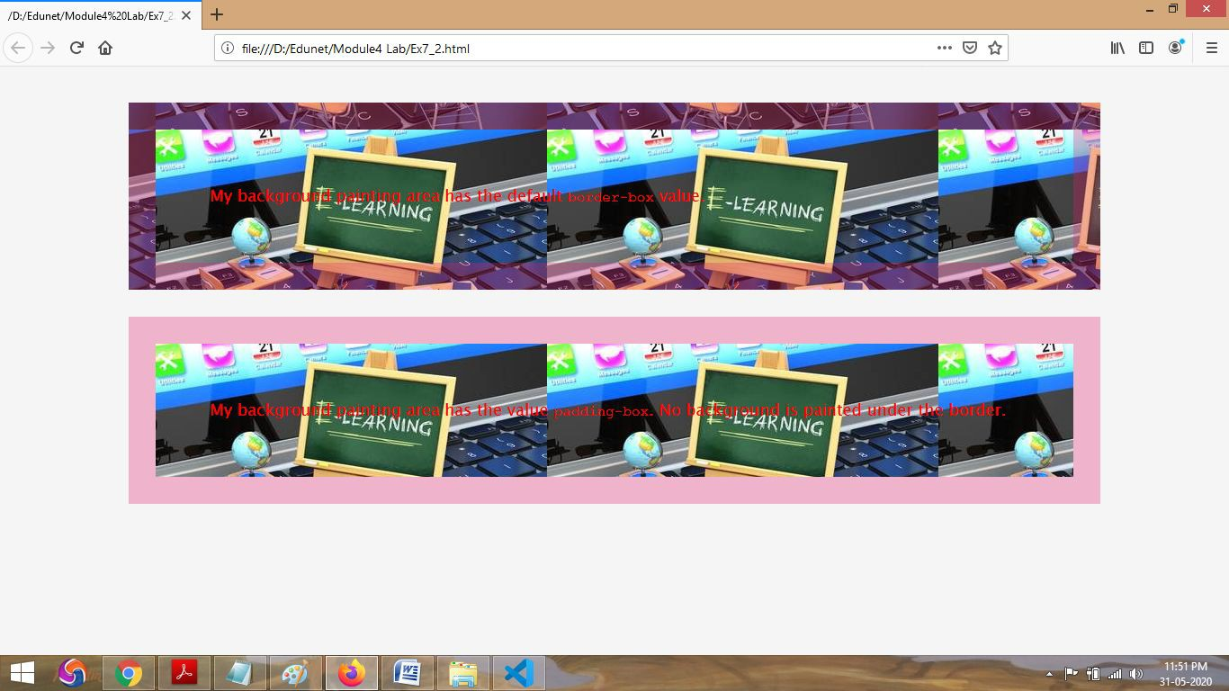

**References:**

● <https://developer.mozilla.org/en-US/docs/Web/CSS>

**Activity 13**

**Aim:** Create fancy boxes (also see the Styling boxes module, generally).

**Learning outcome:** Scripting and styling the web

**Duration:** 1 hour

**List of Hardware/Software requirements:**

● Visual studio code/ Notepad++/ Sublime

● Any One web browser

**Code/Program/Procedure (with comments):**

<!DOCTYPE html>

<head>

<title>Fancy Boxes</title>

<style>

/*fancy-box */

.fancy-box { background: #666; color: #fff;

text-align: center;

border: 5px solid #444;

border-radius: 30px 30px 30px 30px;

padding: 10px;

margin: 1em 0;

}

.fancy-box .fancy-heading {

font-family: Arial;

font-size: 32px;

}

.fancy-box .fancy-button { background: #fff; color: #666;

padding: 1.5em;

}

</style>

</head>

<body>

<div class="fancy-box">

<p class="fancy-heading">This is where you put an amazing title!</p>

</div>

</body>

</html>

**Output/Results snippet:**

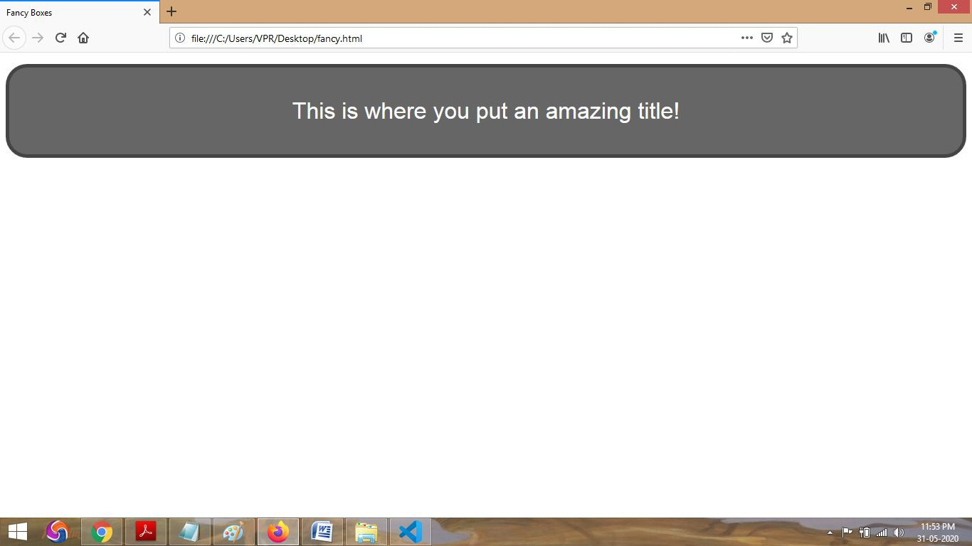

**References:**

● <https://developer.mozilla.org/en-US/docs/Web/CSS>

**Activity 14**

**Aim:** Use background-clip to control background image.

**Learning outcome:** Scripting and styling the web

**Duration:** 1 hour

**List of Hardware/Software requirements:**

● Visual studio code/notepad++/sublime

● Any One web browser

**Code/Program/Procedure (with comments):**

<!DOCTYPE html>

<html>

<head>

<style>

/* Background-Clip */

#example1 {

border: 10px double green;

padding: 15px; background: lightblue; background-clip: border-box;

}

#example2 {

border: 10px dotted rebeccapurple;

padding: 15px; background: lightblue; background-clip: padding-box;

}

#example3 {

border: 10px dotted violet;

padding: 15px; background: lightblue; background-clip: content-box;

}

</style>

</head>

<body>

<h1>The background-clip Property</h1>

<p>The background-clip property defines how far the background should extend within an element.</p>

<p>background-clip: border-box (this is default):</p>

<div id="example1">

<p>The background extends behind the border.</p>

</div>

<p>background-clip: padding-box:</p>

<div id="example2">

<p>The background extends to the inside edge of the border.</p>

</div>

<p>background-clip: content-box:</p>

<div id="example3">

<p>The background extends to the edge of the content box.</p>

</div

<p><strong>Note:</strong> The background-clip property is not supporte d in Internet Explorer 8 and earlier versions.</p>

</body>

</html>

**Output/Results snippet:**

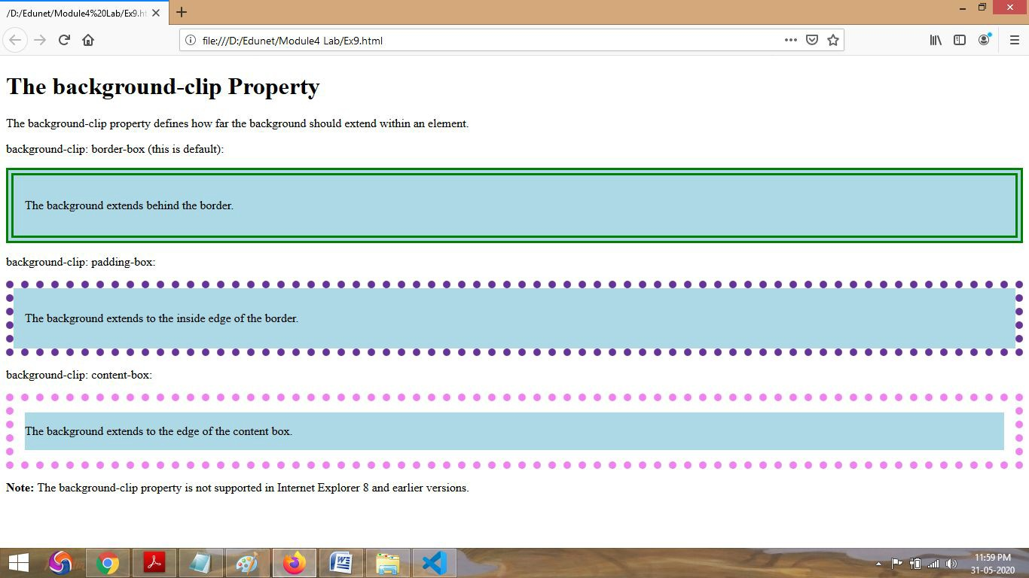

**References:**

● <https://developer.mozilla.org/en-US/docs/Web/CSS>

**Activity 15**

**Aim:** Change the box model completely using box sizing

**Learning outcome:** Scripting and styling the web

**Duration:** 1 hour

**List of Hardware/Software requirements:**

● Visual studio code

● Any One web browser

**Code/Program/Procedure (with comments):**

<!doctype html public "-//w3c//dtd html 4.01//en">

<html>

<head>

<title>box model</title>

<style type="text/css">

/* examples of margins, padding, and borders */

ul {

background: yellow;

margin: 12px 12px 12px 12px;

padding: 3px 3px 3px 3px;

/* no borders set */

}

li {

color: white;

/* text color is white */

background: blue;

/* content, padding will be blue */ margin: 12px 12px 12px 12px; padding: 12px 0px 12px 12px;

/* note 0px padding right */

list-style: none

/* no glyphs before a list item */

/* no borders set */

}

li.withborder {

border-style: dashed;

border-width: medium;

/* sets border width on all sides */

border-color: lime;

}

body {

margin: 2em

}

/* all margins set to 2em */

body {

margin: 1em 2em

}

/* top & bottom = 1em, right & left = 2em */

body {

margin: 1em 2em 3em

}

</style>

</head>

<body>

<ul>

<li>first element of list

<li class="withborder">second element of list is a bit longer to illustrate wrapping.

</ul>

</body>

</html>

**Output/Results snippet**

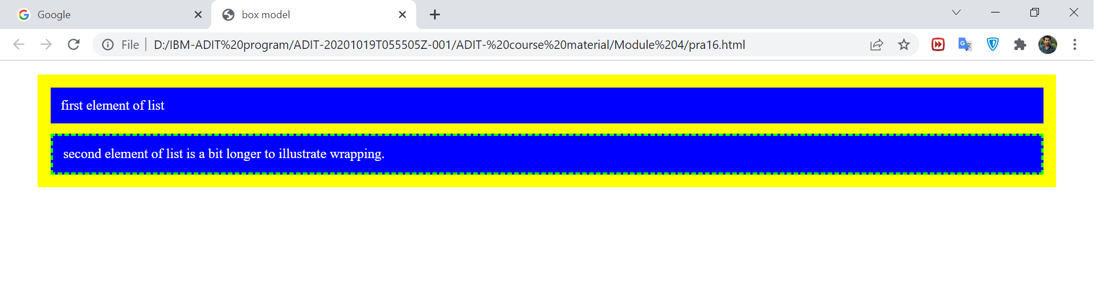

**References:**

● <https://developer.mozilla.org/en-US/docs/Web/CSS>

**Activity 16**

**Aim:** Control backgrounds.

**Learning outcome:** Scripting and styling the web

**Duration:** 1 hours

**List of Hardware/Software requirements:**

● Visual studio code

● Any One web browser

**Code/Program/Procedure (with comments):**

<!DOCTYPE html>

<html>

<head>

<style>

/* Control Backgrounds*/

body {

background-image: url("edu.jpg");

height: 100%;

width: 100%;

/* Center and scale the image nicely */

background-position: center; background-repeat: no-repeat; background-size: cover;

}

h1, p {

font-family: cursive; font-weight: bolder; color: white;

}

div.first {

background: rgba(128, 0, 0, 0.6);

}

div.second {

background: rgba(128, 109, 0, 0.6);

opacity: 0.6;

}

</style>

</head>

<body>

<div class="first">

<h1>Demo Background Property</h1>

</div>

<div class="second">

<p>This text is not easy to read on this background image.</p>

</div>

</body>

</html>

**Output/Results snippet:**

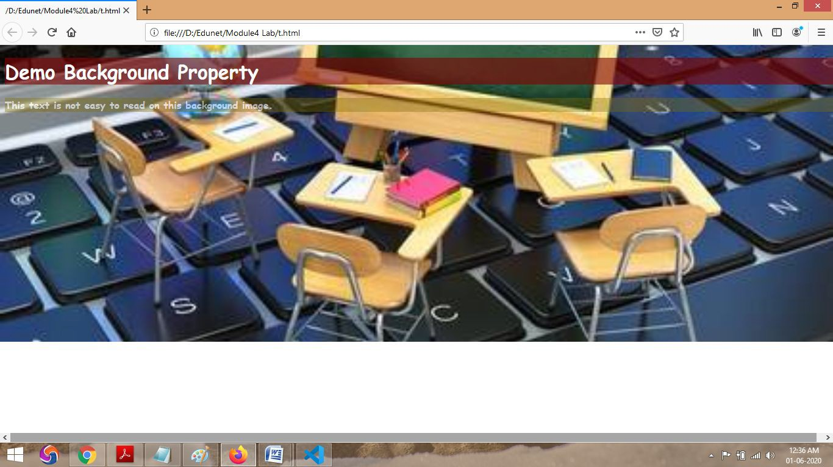

**References:**

● <https://developer.mozilla.org/en-US/docs/Web/CSS>

**Activity 17**

**Aim:** Apply control borders

**Learning outcome**: Able to understand how the web works.

**Duration: 1 Hours**

**List of Hardware/Software requirements:**

1. HTML Editor : Sublime Text Editor

2. Web Browser : Google Chrome/Mozilla Firefox

**Code/Program/Procedure (with comments):**

<html>

<head>

<style>

/* Define look of the table */

table {

border-width: 3px;

background-color: #52E396;

}

tr, td {

padding: 2px;

}

/* border-style example classes */

.b1 {border-style:none;}

.b2 {border-style:hidden;}

.b3 {border-style:dotted;}

.b4 {border-style:dashed;}

.b5 {border-style:solid;}

.b6 {border-style:double;}

.b7 {border-style:groove;}

.b8 {border-style:ridge;}

.b9 {border-style:inset;}

.b10 {border-style:outset;}

</style>

</head>

<body>

<table>

<tr>

<td class="b1">none</td>

<td class="b2">hidden</td>

<td class="b3">dotted</td>

<td class="b4">dashed</td>

</tr>

<tr>

<td class="b5">solid</td>

<td class="b6">double</td>

<td class="b7">groove</td>

<td class="b8">ridge</td>

</tr>

<tr>

<td class="b9">inset</td>

<td class="b10">outset</td>

</tr>

</table>

</body>

</html>

**Output/Results snippet:**

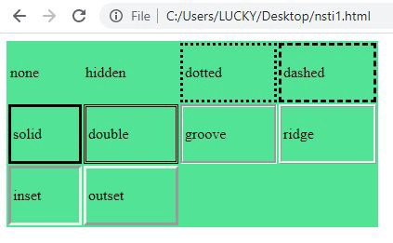

**References:**

● <https://www.w3schools.com/css/css_border.asp>

● <https://www.html.am/html-codes/tables/table-border.cfm>

● <https://www.w3schools.com/css/css_border.asp>

**Activity 18**

**Aim:** Style an HTML table

**Learning outcome**: Able to understand how the web works.

**Duration:** 3 Hours

**List of Hardware/Software requirements:**

3. HTML Editor : Sublime Text Editor

4. Web Browser : Google Chrome/Mozilla Firefox

**Code/Program/Procedure (with comments):**

<!DOCTYPE html>

<html>

<head>

<style>

#customers {

font-family: "Trebuchet MS", Arial, Helvetica, sans-serif;

border-collapse: collapse;

width: 100%;

}

#customers td, #customers th { border: 1px solid #ddd; padding: 8px;

}

#customers tr:nth-child(even){background-color: #f2f2f2;}

#customers tr:hover {background-color: #ddd;}

#customers th { padding-top: 12px; padding-bottom: 12px; text-align: left;

background-color: #4CAF50;

color: white;

}

</style>

</head>

<body>

<table id="customers">

<tr>

<th>Company</th>

<th>Contact</th>

<th>Country</th>

</tr>

<tr>

<td>Alfreds Futterkiste</td>

<td>Maria Anders</td>

<td>Germany</td>

</tr>

<tr>

<td>Berglunds snabbköp</td>

<td>Christina Berglund</td>

<td>Sweden</td>

</tr>

<tr>

<td>Centro comercial Moctezuma</td>

<td>Francisco Chang</td>

<td>Mexico</td>

</tr>

<tr>

<td>Ernst Handel</td>

<td>Roland Mendel</td>

<td>Austria</td>

</tr>

<tr>

<td>Island Trading</td>

<td>Helen Bennett</td>

<td>UK</td>

</tr>

<tr>

<td>Königlich Essen</td>

<td>Philip Cramer</td>

<td>Germany</td>

</tr>

<tr>

<td>Laughing Bacchus Winecellars</td>

<td>Yoshi Tannamuri</td>

<td>Canada</td>

</tr>

<tr>

<td>Magazzini Alimentari Riuniti</td>

<td>Giovanni Rovelli</td>

<td>Italy</td>

</tr>

<tr>

<td>North/South</td>

<td>Simon Crowther</td>

<td>UK</td>

</tr>

<tr>

<td>Paris spécialités</td>

<td>Marie Bertrand</td>

<td>France</td>

</tr>

</table>

</body>

</html>

**Output/Results snippet:**

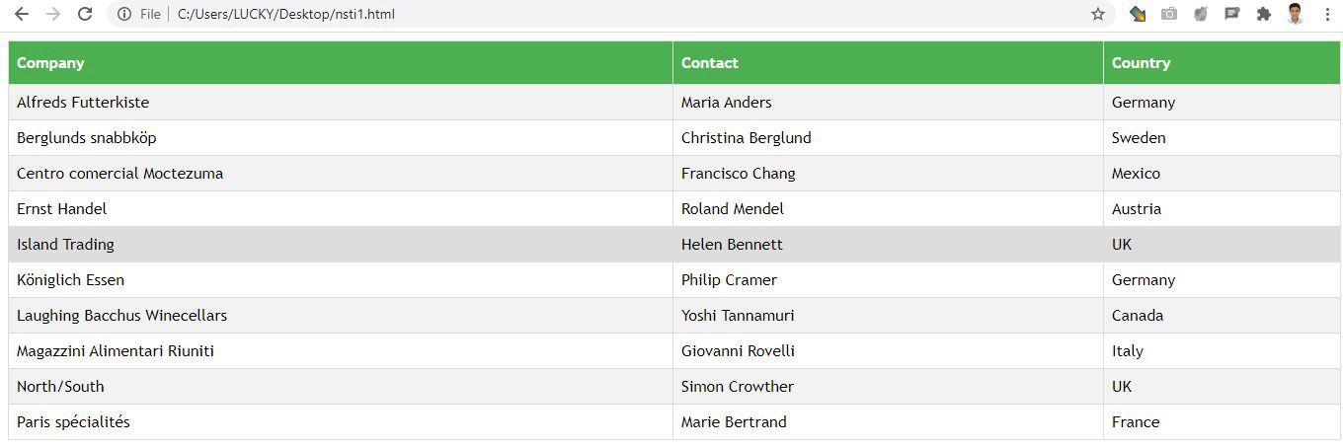

**References:**

● <https://www.w3schools.com/css/css_table.asp>

**Activity 19**

**Aim:** Add shadows to boxes

**Learning outcome**: Able to understand how the web works.

**Duration: 2 Hours**

**List of Hardware/Software requirements:**

1. HTML Editor : Sublime Text Editor

2. Web Browser : Google Chrome/Mozilla Firefox

**Code/Program/Procedure (with comments):**

<!DOCTYPE html>

<html>

<head>

<style>

#example1 { border: 1px solid; padding: 10px;

box-shadow: 5px 5px blue, 10px 10px red, 15px 15px green;

}

#example2 {

border: 1px solid;

padding: 10px;

box-shadow: 5px 5px 8px blue, 10px 10px 8px red, 15px 15px 8px green;

}

</style>

</head>

<body>

<h2>box-shadow: 5px 5px blue, 10px 10px red, 15px 15px green:</h2>

<div id="example1">

<p>Define multiple shadows.</p>

</div>

<h2>box-shadow: 5px 5px 8px blue, 10px 10px 8px red, 15px 15px 8px green:</h2>

<div id="example2">

<p>Define multiple shadows with blur effect.</p>

</div>

</body>

</html>

**Output/Results snippet:**

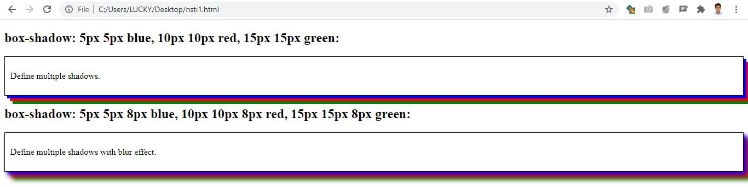

**References:**

● <https://www.w3schools.com/cssref/css3_pr_box-shadow.asp>

● <https://www.w3schools.com/css/css3_shadows.asp>

**Activity 20**

**Aim:** Calculate specificity of a CSS selector

**Learning outcome**: Able to understand how the web works.

**Duration: 3 Hours**

**List of Hardware/Software requirements:**

3. HTML Editor : Sublime Text Editor

4. Web Browser : Google Chrome/Mozilla Firefox

**Code/Program/Procedure (with comments):**

<!DOCTYPE html>

<html>

<head>

<style>

/*Element Selector*/

h1

{background-color: yellow;

text-align: center;}

/*Class Selector*/

.center {

background-color: red; text-align: center; color: green;

}

/*id selector*/

#header{

background-color: blue;

text-align: center;

color: red;

font-size:36px;

}

</style>

</head>

<body>

<h1>This is heading 1 element selector</h1>

<h1 class="center">This is heading 2 .Center class selector</h1>

<p id="header">This is #id selector</p>

</body>

</html>

**Output/Results snippet:**

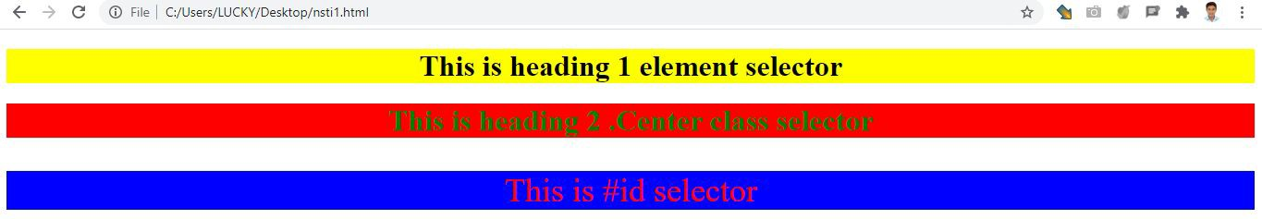

**References:**

● <https://www.w3schools.com/css/css_selectors.asp>

**Activity 21**

**Aim:** Control Inheritance in CSS

**Learning outcome**: Able to understand how the web works.

**Duration: 2 Hours**

**List of Hardware/Software requirements:**

1. HTML Editor : Sublime Text Editor

2. Web Browser : Google Chrome/Mozilla Firefox

**Code/Program/Procedure (with comments):**

<!DOCTYPE html>

<html>

<head>

<style>

span {

color: blue;

border: 1px solid black;

}

.extra span {

color: inherit;

}

</style>

</head>

<body>

<div>

Here is <span>a span element</span> which is blue, as span elements are set to be.

</div>

<div class="extra" style="color:green">

Here is <span>a span element</span> which is green, because it inherits from its parent.

</div>

<div style="color:red">

Here is <span>a span element</span> which is blue, as span elements are set to be.

</div>

</body>

</html>

**Output/Results snippet:**

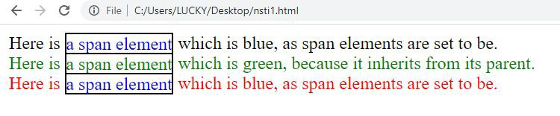

**References:**

● [https://stackoverflow.com/questions/641217/css-control-inheritance-inheriting-other-cont rol-styles](https://stackoverflow.com/questions/641217/css-control-inheritance-inheriting-other-control-styles)

**Activity 22**

**Aim: Apply filters in CSS**

**Learning outcome**: Able to understand how the web works.

**Duration:** 2 Hours

**List of Hardware/Software requirements:**

1. HTML Editor : Sublime Text Editor

2. Web Browser : Google Chrome/Mozilla Firefox

**Code/Program/Procedure (with comments):**

<!DOCTYPE html>

<html>

<head>

<style>

img {

-webkit-filter: grayscale(100%); /* Safari 6.0 - 9.0 */

filter: grayscale(100%);

}

</style>

</head>

<body>

<h1>The filter Property</h1>

<p>Convert the image to grayscale:</p>

<img src="download.png" alt="CSS" width="300" height="300">

<p><strong>Note:</strong> The filter property is not supported in Internet Explorer, Edge

12, or Safari 5.1 and earlier.</p>

</body>

</html>

**Output/Results snippet:**

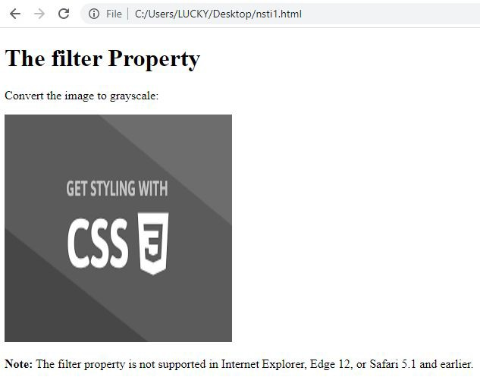

**References:**

● <https://www.w3schools.com/cssref/css3_pr_filter.asp>

**Activity 23**

**Aim:** Apply blend modes in CSS

**Learning outcome**: Able to understand how the web works.

**Duration:** 2 Hours

**List of Hardware/Software requirements:**

1. HTML Editor : Sublime Text Editor

2. Web Browser : Google Chrome/Mozilla Firefox

**Code/Program/Procedure (with comments):**

<!DOCTYPE html>

<html>

<head>

<style>

#myDIV { width: 400px; height: 400px;

background-repeat: no-repeat, repeat;

background-image: url("img_5terre.jpg"),url("download.png");

background-blend-mode: lighten;

}

</style>

</head>

<body>

<h1>The background-blend-mode Property</h1>

<div id="myDIV"></div>

<p><b>Note:</b> Edge/Internet Explorer do not support the background-blend-mode property.</p>

</body>

</html>

**Output/Results snippet:**

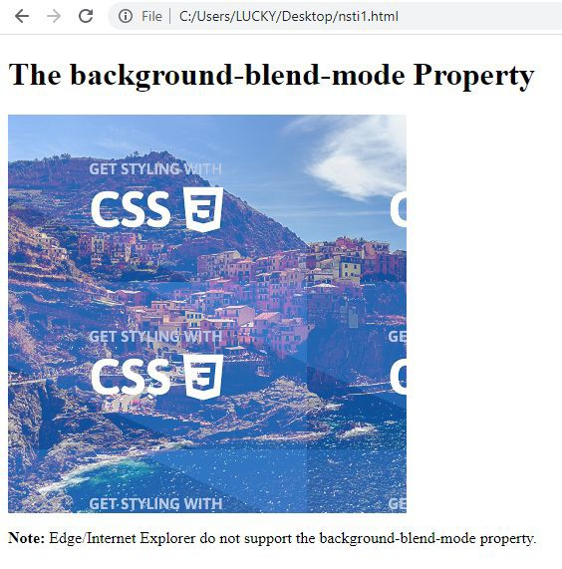

**References:**

● <https://www.w3schools.com/cssref/pr_background-blend-mode.asp>

**Activity 24**

**Aim:** Apply CSS multi-column layouts

**Learning outcome**: Able to understand how the web works.

**Duration:** 3 Hours

**List of Hardware/Software requirements:**

1. HTML Editor : Sublime Text Editor

2. Web Browser : Google Chrome/Mozilla Firefox

**Code/Program/Procedure (with comments):**

<!DOCTYPE html>

<html>

<head>

<style>

.newspaper {

-webkit-column-count: 3; /* Chrome, Safari, Opera */

-moz-column-count: 3; /* Firefox */

column-count: 3;

-webkit-column-gap: 40px; /* Chrome, Safari, Opera */

-moz-column-gap: 40px; /* Firefox */

column-gap: 40px;

-webkit-column-rule-style: solid; /* Chrome, Safari, Opera */

-moz-column-rule-style: solid; /* Firefox */

column-rule-style: solid;

}

</style>

</head>

<body>

<p><b>Note:</b> Internet Explorer 9, and earlier versions, does not support the columnrule-style property.</p>

<div class="newspaper">

HyperText Markup Language (HTML) is a markup language[1] for creating a webpage. Webpages are usually viewed in a web browser. They can include writing, links, pictures,

and even sound and video. HTML is used to mark and describe each of these kinds of content so the web browser can display them correctly. HTML can also be used to add meta information to a webpage. Meta information is usually not shown by web browsers and is

data about the web page, e.g., the name of the person who created the page. Cascading Style Sheets (CSS) is used to style HTML elements while JavaScript is used to manipulate HTML elements and CSS styles.

</div>

</body>

</html>

**Output/Results snippet:**

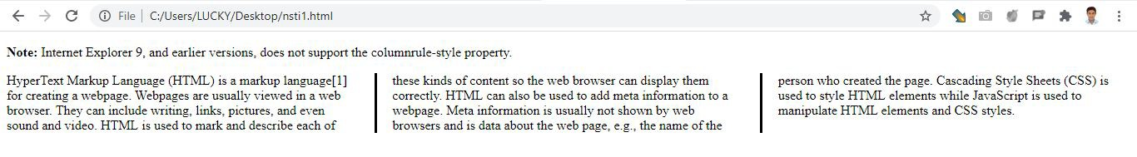

**References:**

● <https://www.w3schools.com/css/css3_multiple_columns.asp>

**Activity 25**

**Aim: Apply CSS generated Content**

**Learning outcome**: Able to understand how the web works.

**Duration:** 2 Hours

**List of Hardware/Software requirements:**

1. HTML Editor : Sublime Text Editor

2. Web Browser : Google Chrome/Mozilla Firefox

**Code/Program/Procedure (with comments):**

<!DOCTYPE html>

<html>

<head>

<style>

ul {

list-style: none; /* Remove HTML bullets */

padding: 0; margin: 0; } li {

padding-left: 16px; }

li::before {

content: "•"; /* Insert content that looks like bullets */

padding-right: 8px;

color: blue; /* Or a color you prefer */ }

</style>

</head>

<body>

<h1>The content Property</h1>

<ul>

<li>Coffee</li>

<li>Tea</li>

<li>Coca Cola</li>

</ul>

</body>

</html>

**Output/Results snippet:**

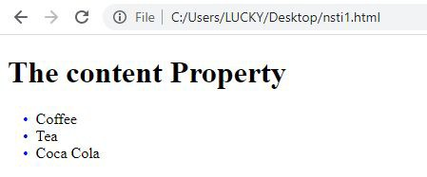

**References:**

● <https://www.w3schools.com/cssref/pr_gen_content.asp>